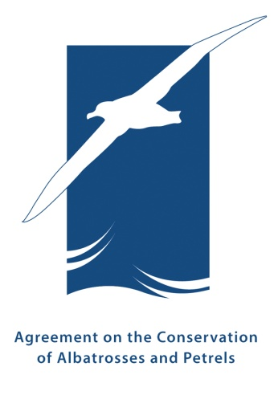 | Fifteenth Meeting of the Advisory Committee  Swakopmund, Namibia, 1 – 5 June 2026  Title  Author

SUMMARY
If applicable. 300 words max.
RECOMMENDATIONs
For Working Documents only. 150 words max.
- Recommendation.
- Recommendation.
- Recommendation.

1. Header level One
  - 1.1. Header level two
Text here text text text text text text text text. Text here text text text text text text text text text text text text text text.
- Multilevel list – level 1
  - multilevel list - level 2.
  - multilevel list – level 2
    - multilevel list – level 3
    - multilevel list – level 3
- Multilevel list
- Multilevel list

2. Header level One
  - 2.1. Header level two
    - 2.1.1. Header level three
Text here text text text text text text text text text text text text text text. Text here text text text text.

